8c.v | tiziano maresca
27/9/2018
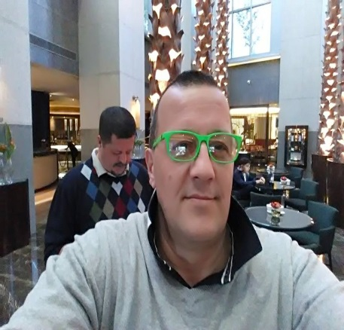 | Via San Nemesio 16 00145 Roma  +39 3664324409  tittachef@live.it  [Digitare l'indirizzo del sito Web]

Obiettivi
[Digitare gli obiettivi]
Istruzione
Istituto tecnico commerciale Kennedy
07 1990
Account degree
Italian chef degree

esperienze professionali
chef | S’INCONTRO restaurant
Oct 2018 – Dicember 2019
Mauritius
Create menu and training crew
chef | PULCINELLARESTAURANT
May 2018 – september 2018
Create menu and training crew

Executive chef at Di Lusso restaurant
Riyadh South Arabia
Jenuary 2018 April 2018
Training and Coun
salting

Executive chef at Harry’s Bar in Rome
April 2017 december 2017
Counsalting

Executive chef at Il Pellicano Cucina Italiana
Caya Caulker Belize
April 2015 Jenuary 2017
Counsiltin and training

Chef at Pulcinella restauracnt
Toronto Canada
April 2014 April 2015
Supervisor

Executive chef at Tiziano
Shanghai China
June 2013 February 2014
Counsalting and Trainer

Executive chef at Pulcinella Restaurant
Toronro Canada
September 2012 April 2013
Supervisor

Executive chef at Appassionato Restaurant
Taichung Taiwan
October 2011 May 2012
Training and cousulting

Chef at Mario Resttaurant
Eraklion Greece
October 2010 June 2011
Supervisor

Chef Alla Rampa
Rome Italy
September 2009 September 2010
Speciality Fish Chef

Executive Chef at Moka caffe
Rome Italy
June 2008 August 2009
Training for roman Traditional Food

Executive Chef at Esco Pazzo
Rome Italy
June 2005 April 2008
Supervisor

Executive Chef at Piazza Rome
Tampa Florida U.S.A.
April 2004 May 2005
Supervisor and Training for Rome Traditional Food

Chef de Partie at The Place
Rome Italy
September2001 Jenuary 2004
Supervisor for meat and fish Area

Manager at Pasqualino al Colosseo
Rome Italy
August 1998 July 2001

Manager at Paper Moon
San Diego California U.S.A.
March 1997 June 1998

Manager at Ponte Vecchio Restaurant
New York U.S.A.
April 1994 December 1996

Military Service
Italy
December 1992 December 1993

Technician Oceanographic
Mediterranean Survey & Service
Rome Italy
Agoust 1990 November 1992

competenze
- Training staff in Italian Food
- Training Staff for Italian Wine
- Training Staff for SERVICE
- Food cost

English spoke and write
Spanish spoke

